Suburban tailgate power window repair

So today I went to get mulch and guess what. Back window won't roll up! Nothing.
So I try the basics. Pull dash switch out, bypass with jumper wire in connector. Nothing.
Pull panel off tailgate. CRAP. Windows down, and LIMO tinted so can't access anything yet alone see through the window.
Grab test light, check wires coming into tailgate. Figure out blue is from switch for window up, tan (some call it pink) is from switch for power down.
Both get power from harness on dash when jumpered, window still does nothing.
Next I do what any sane person would do.
I come in the house and hop on COLORADOK5!
Found way too many threads to read through so I get the just of things and go back to it.
This time I take my camera since none of the threads had pictures.
I decided to just tear into everything. The window previously worked OK, but was slow, and the key NEVER worked on the outside.
I hate opening the truck, putting the key in the ignition, rolling the window down, putting stuff in and yada yada. I just want the darn thing to work from the key.
SO, I now have a tailgate that works better than before, the window goes up and down with both the dash switch AND THE KEY NOW!!!
Turns out the reason the key wasn't working is the connector in the always on power wire to the key switch was fubared inside. Looked fine outside.
Cut it off and soldered the wires. Of course the troubleshooting to get to this point took forever. Mainly because I never thought to check the wire going INTO the connector. Just pulled it apart and checked the terminals.
Also learned the hard way the dash switch has 2 LITTLE springs that it needs to work. When I tried to pull the harness off the connector the guts came out instead and the springs flew out without me noticing it. It wasn't until I was cleaning the contacts and greasing them I noticed the 2 cavities for the springs.
All in all it was a pretty easy job, just thought I would post pics of everything to hopefully save someone the hoops I went though, and to show how easy these things are to take apart. I was dreading it until now.
Some guys say the problem might be the safety switch on the latch.
Mine is a 1987 burb, and the safety switch is on the passenger side latch. You can see it from the outside. I pulled it off with a pair of long angled needle nose pliers, then to make sure I didn't drop it in the tailgate, (this was in the very beginning before I tore into things. Start simple) then made a small jumper wire with 2 spade connectors on the end. Jump the wires. I still had nothing.
Here's pics from the outside and then from the inside once I tore it apart.
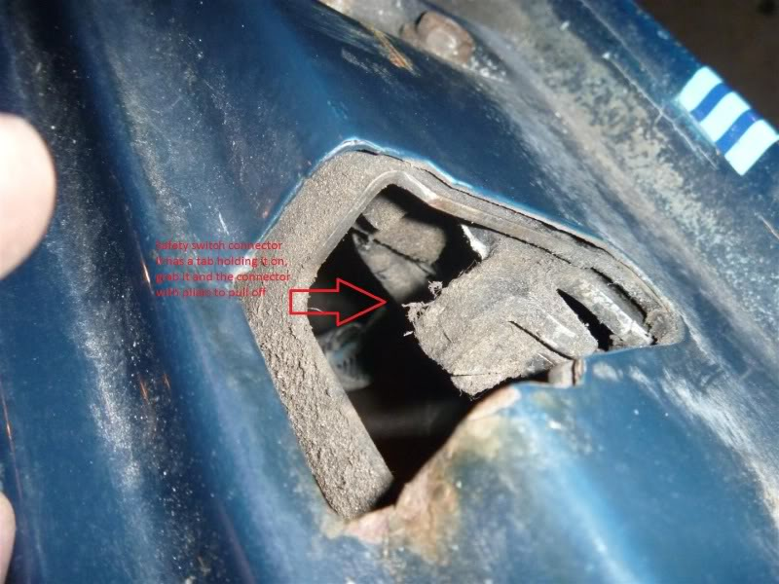
Here's another from the outside but inside lighting
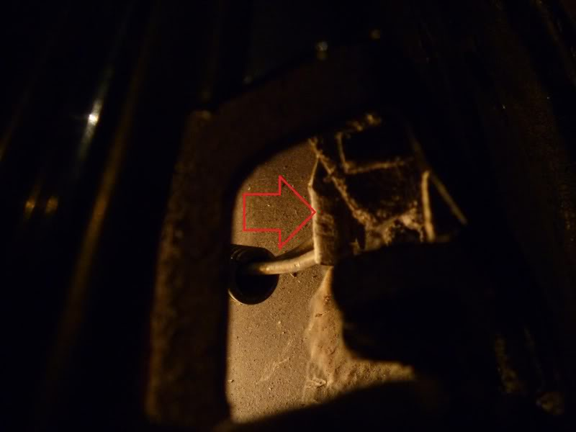
And here's one from inside the tailgate
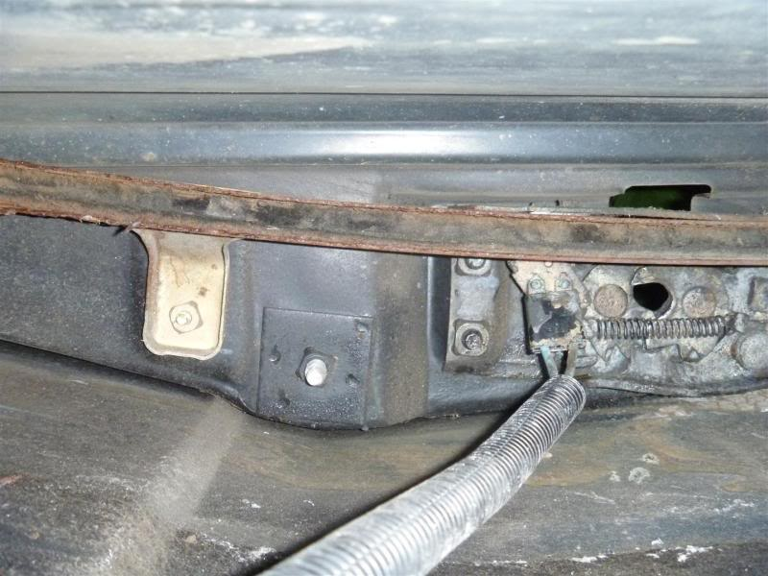
This was all working fine in the end.
Tested the motor, it worked fine when I jumpered straight to the battery.
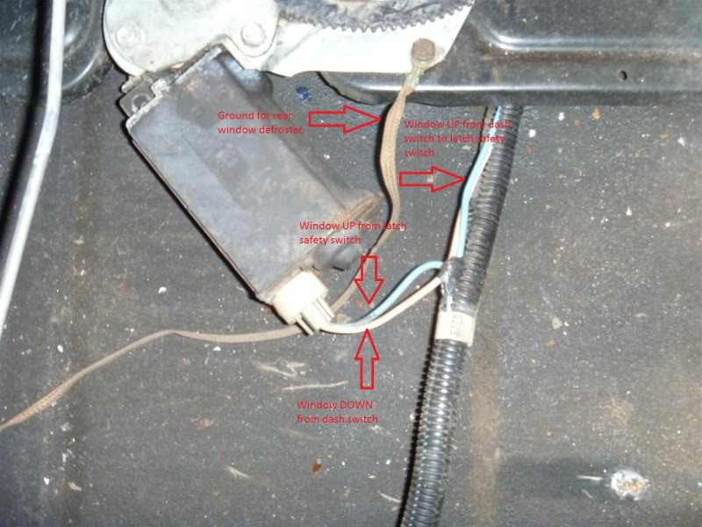
Here's where the problem for the key switch ended up being. Behind the bumper. I already had the bumper off for paint and body.
The orange with a black stripe wire is where the key gets its always on power. The connector was bad. I pulled it apart, looked fine, ended up later on stabbing the frame side of the wire before the connector. Had power but not though the connector so I cut it and soldered.
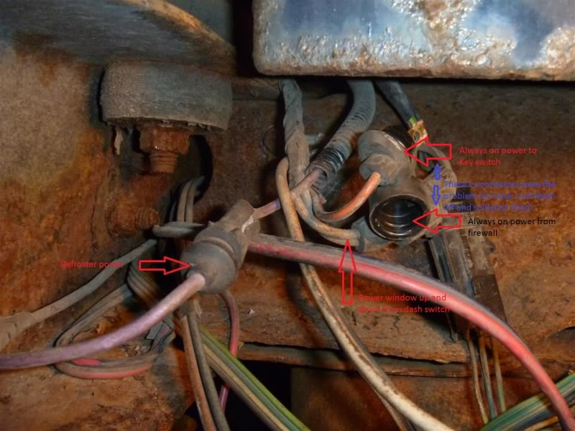
The regulator is held in by 4 bolts. Easy to get out. BTW I did have to drill 4 holes in the tailgate to get to the four 7/16” bolts holding the window onto the regulator since the window was stuck in the down position. I greased everything while it was out.
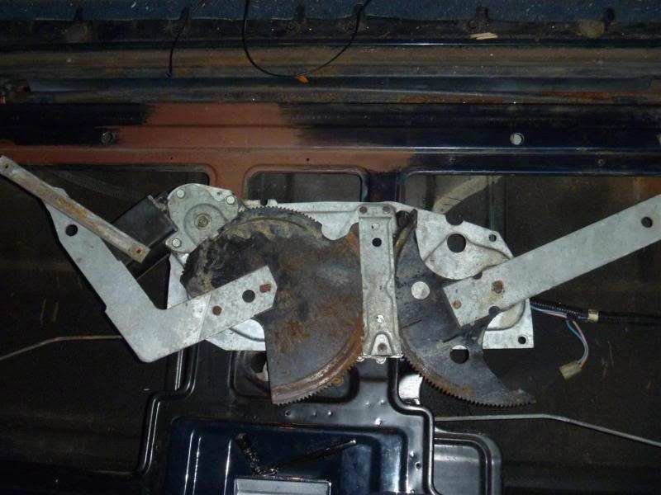
This is behind the regulator. The back of the key switch. Two 7/16” nuts hold it on.
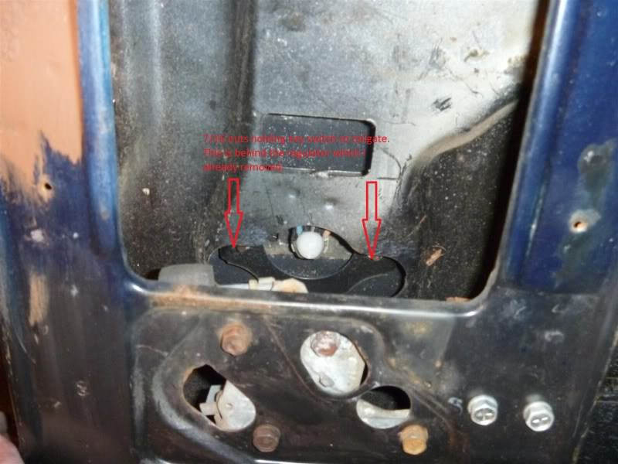
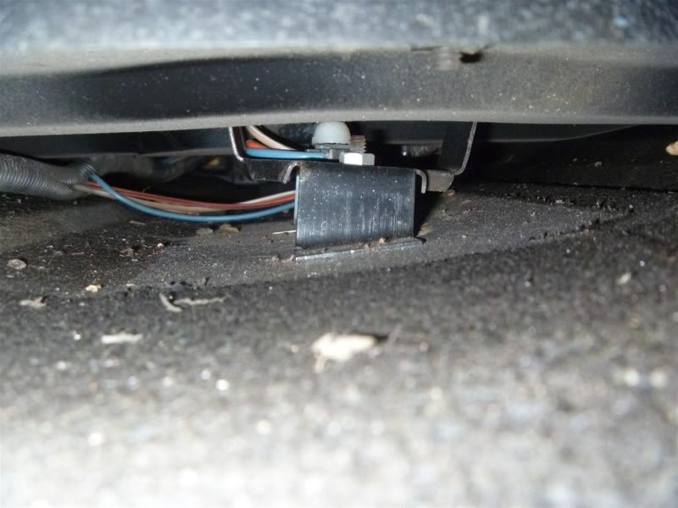
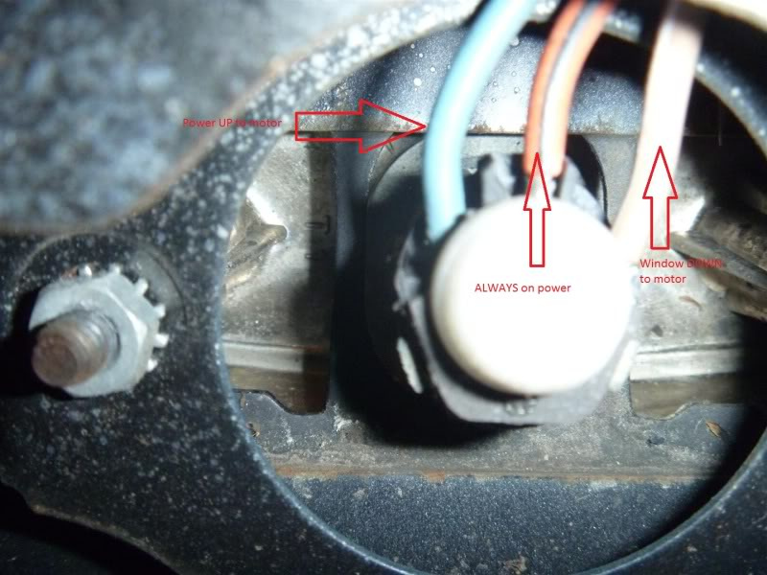
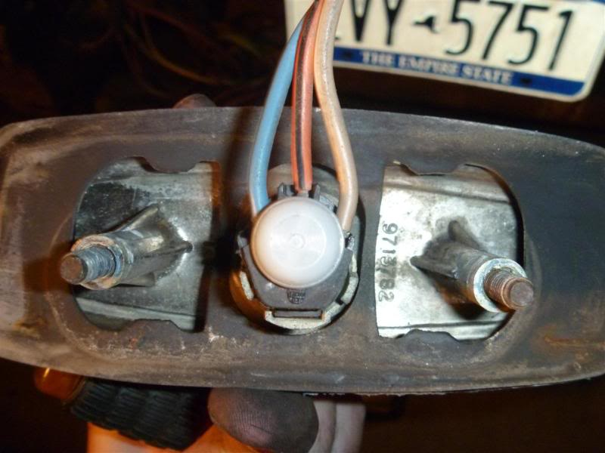
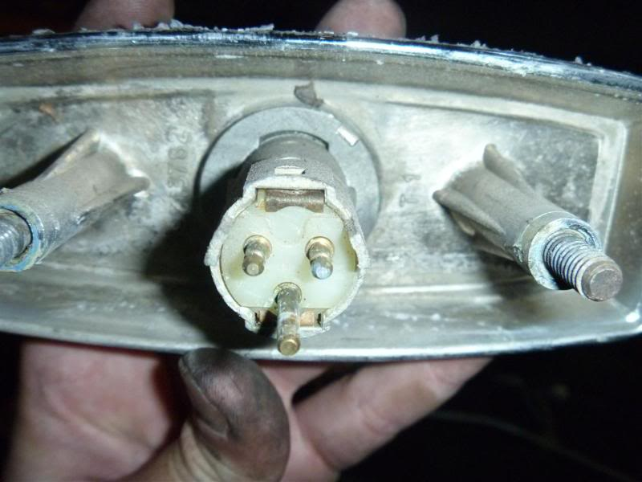
SO, if your key quits working, I hope this helps. It's easy, just time consuming. Overall I spent 3 hours on this.

