FORD
Modifying both power windows for express up and down.
This is how I modified my power windows to work as express up and down using express modules out of a 92-95 Ford Taurus. These can be bought new or you can find them on ebay and in junkyards. The modules don't have to come out of a Taurus as long as they look like this, come from a Ford and have 5 wires it should work.
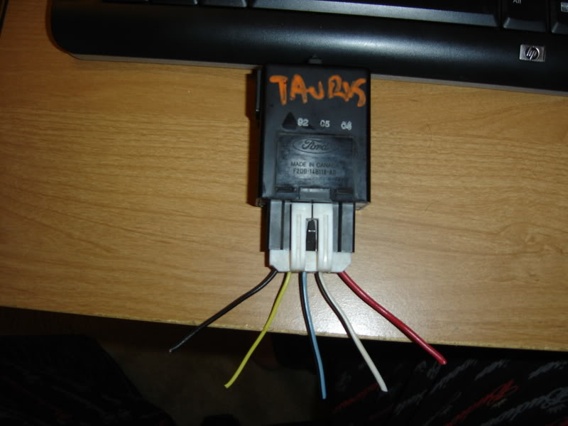
Stuff you need:
3 express window modules (1 module for each direction)
Wire stripper and cutter
Wire
Butt connectors
tools to remove door panel
Let’s start with the passenger door. Start by removing the door panel and the foam behind the door panel. Locate a good spot inside the door for two of the modules (A and B) that will be out the way of the window going up and down.
Before you mount your modules in the door extend all the wires so that they can reach the wires going up to the power window switch. On the modules there are 5 wires and depending on the model and year of your modules the wire colors are different. If you look at the module with the Ford logo facing away from you, the first thick wire we will call wire 1 it usually red but I'm not sure if it is on all modules, and so on down the line. Wire 5 should be a smaller black wire on all the modules. Here is where each wire will go:
wire 1 - to motor
wire 2 - to switch
wire 3 - accessory power
wire 4 - opposite direction
wire 5 - ground
Next you need to figure out which wire does what on the pass. switch only. On my 06 ZX3 the wire colors are:
yellow/purple = up
green/white = accessory power
White/purple = down
Black = ground
here is a pic of the passenger side window switch.
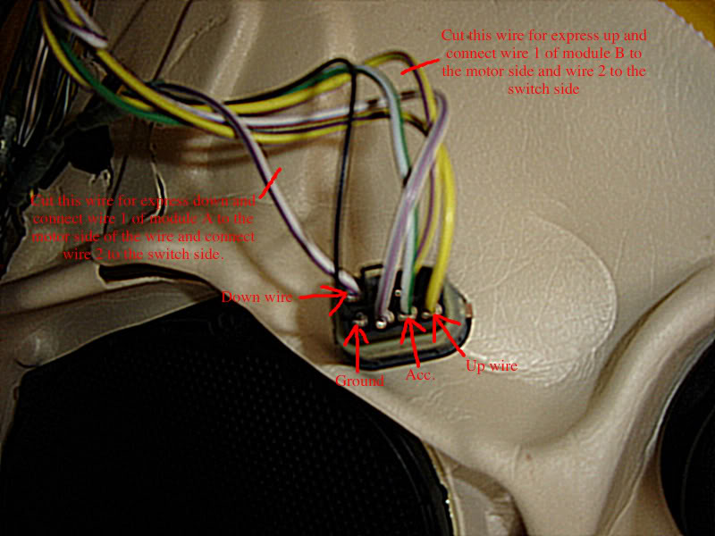
To wire module (A) for express down you need to cut the wire that supplies power to the down side of the motor. Connect wire 1 to the motor side of the wire you cut. Connect wire 2 to the switch side of wire you cut. Connect wire 3 to the accessory wire. Connect wire 4 into the wire that supplies power to the up side of the switch. Connect wire 5 to either the ground from the window switch or to a good ground on the door.
To wire the second module (B) for express up you need to cut the wire that supplies power to the up side of the motor and wire the same as the first module. If doing both up and down you can save some connectors by wiring both number 3’s together then connecting them to the accessory wire. Connect both grounds together then connect them to the ground. Connect wire 2 from module A to wire 4 of module B then connect to thedown switch wire. Connect wire 4 from module A to wire 2 of module B then connect to the up switch wire. That last part sounds kind complicated but once you get that far you will see what I mean.
Here is a pic of a wire diagram I made with my awesome paint skills. I hope it helps.
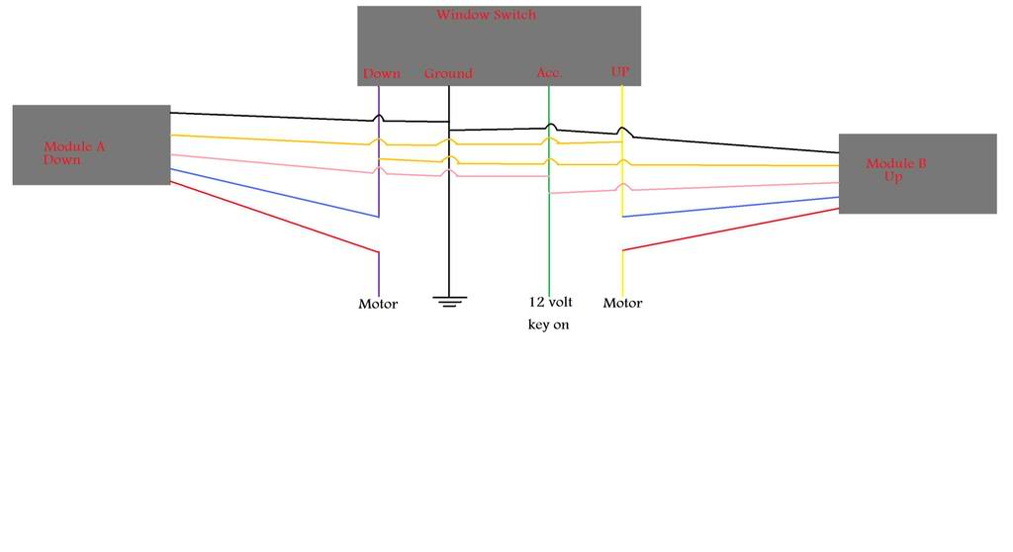
If everything is done correctly the express features should work for the passenger window from the driver side switch. The switchs will still work as a normal switchs in that if you tap the switch it goes into express mode, and if you hold the switch like a normal one it will stop when you let off. The only thing that is different is that if you want to stop the window when in express mode, you need to tap the switch again in the same direction the window is going.
To do the driver side, you will need to do the same process as the passenger side, but if you already have factory express down, then you will only need one module for express up.

