Drum brake assembly
Assembly sequence for a "typical" GM drum brake
1966 GM half-ton pickup (Delco Shown, Bendix similar)
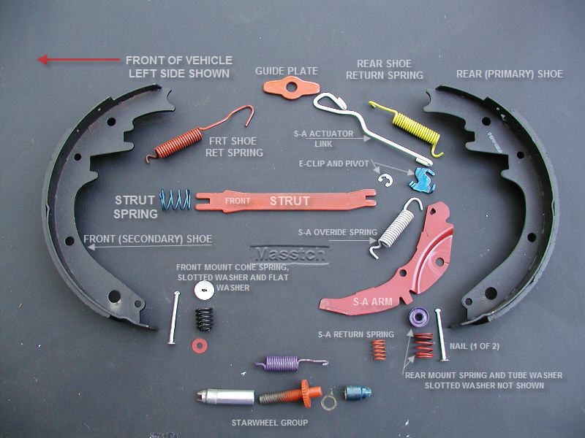
The parts pile, excluding park lever and pushrods.
NOTE: colors are random paints I had on hand. Not "color-coded"
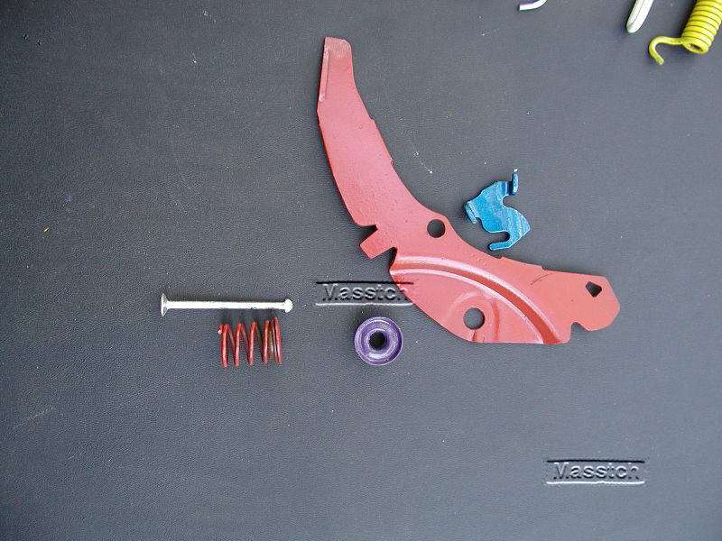
Self adjuster (SA arm) group
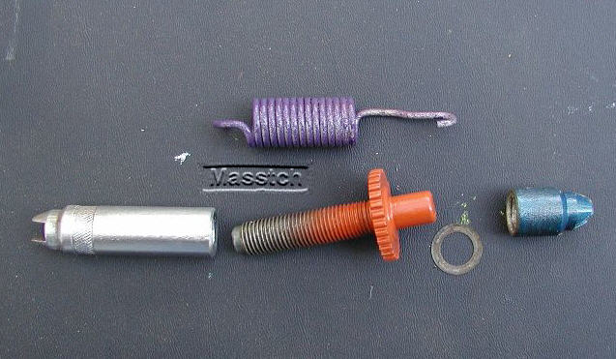
Adjuster wheel group

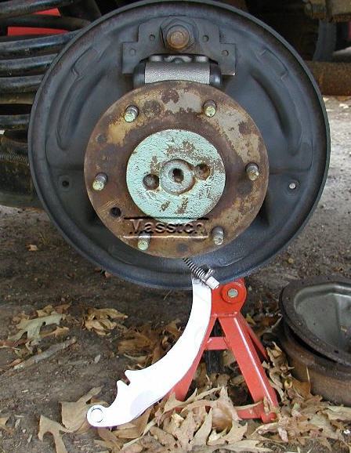
Where it all goes
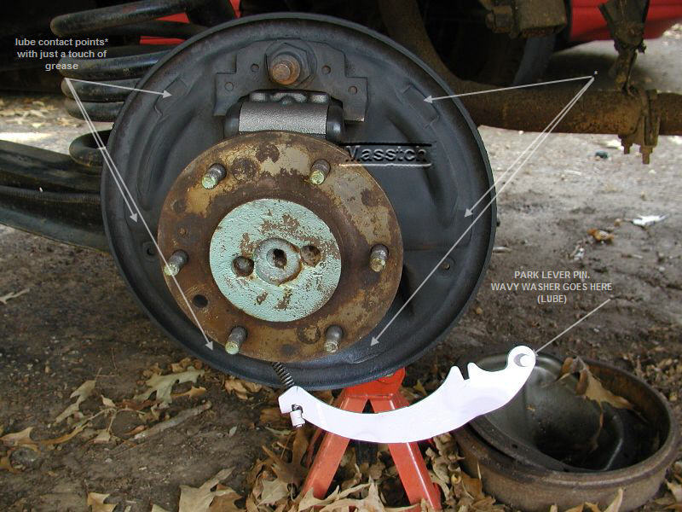
Park brake lever on the cable

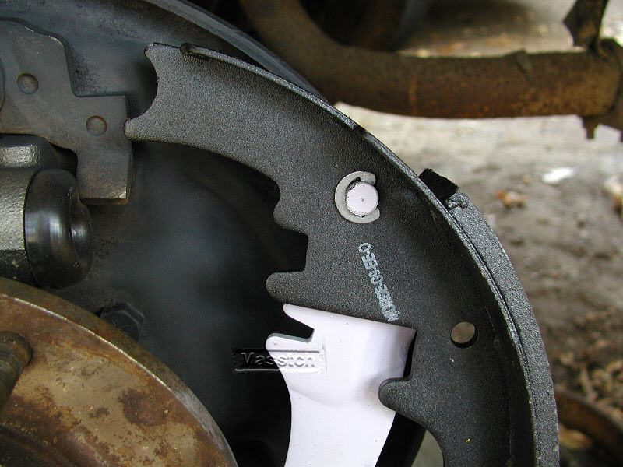
Start here: lube park lever pin and wavy washer, install thru rear shoe, add the "Jesus clip"
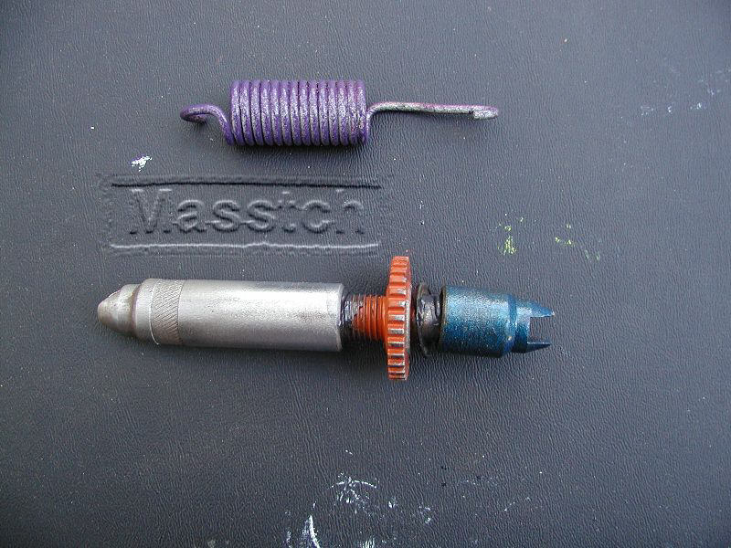
Lube Starwheel shaft & threads with chassis grease or moly lube; thread the adjuster together but do not tighten
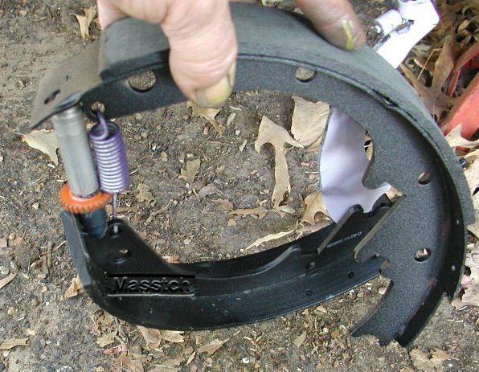
star wheel end goes toward rear shoe.
NOTE!
Left-hand threaded adjuster screw is for RIGHT (passenger) side brake
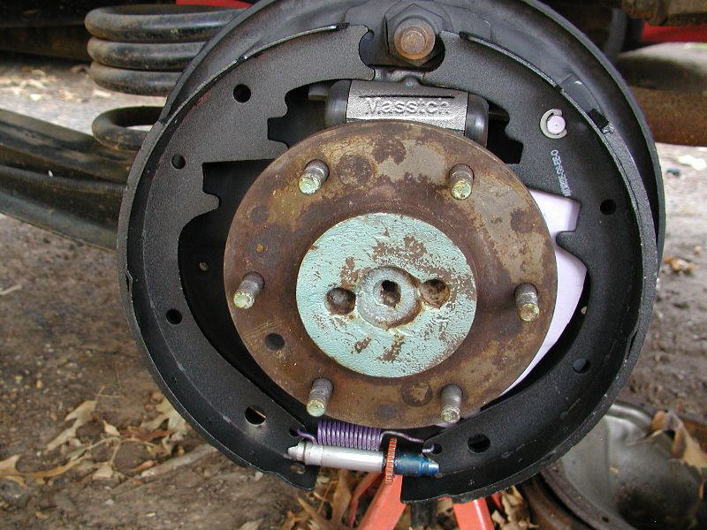
spread shoes over axle, set against backplate
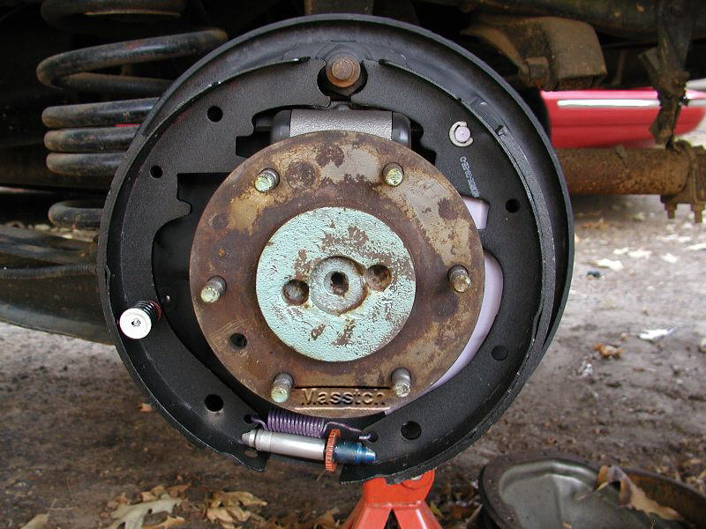
put washer & cone spring on "nail" thru front shoe. Place pushrods in cylinder
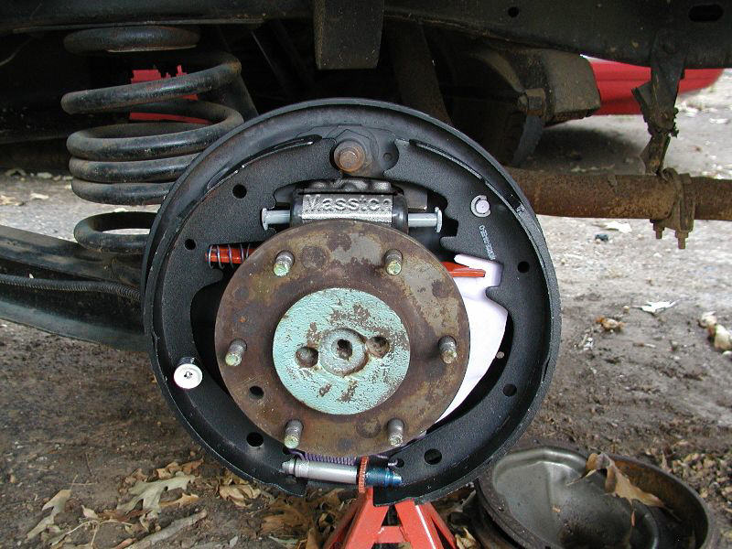
place strut and spring between shoes.
Note position! It is installed in this pic exactly as it is shown in the parts pile above
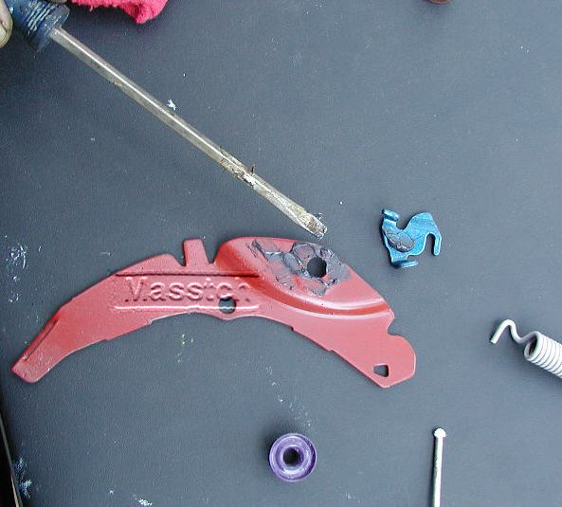
Lube contact areas on SA arm and pivot
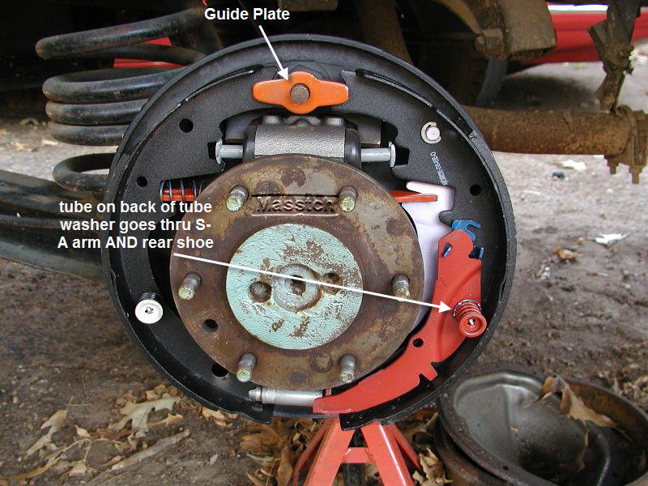
put guide on anchor. place SA arm with pivot on rear shoe with nail, tube washer & straight spring
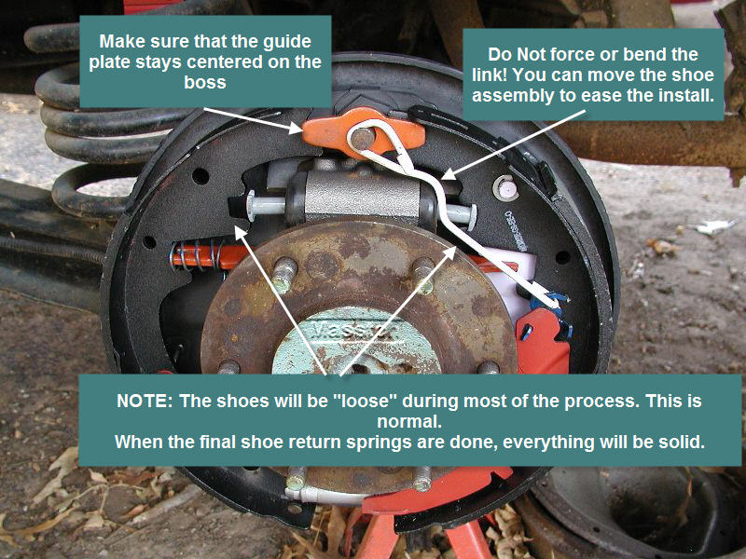
Add actuator link, follow with overide spring from arm to pivot (next pic)
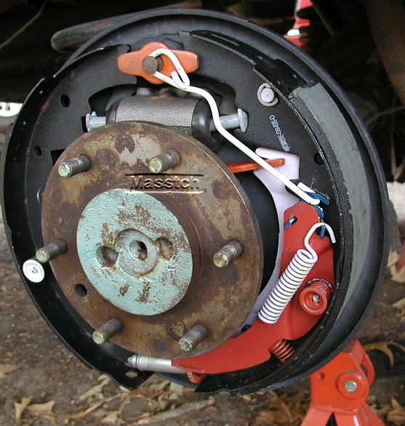
Place return spring under SA arm. note placement of pivot and link
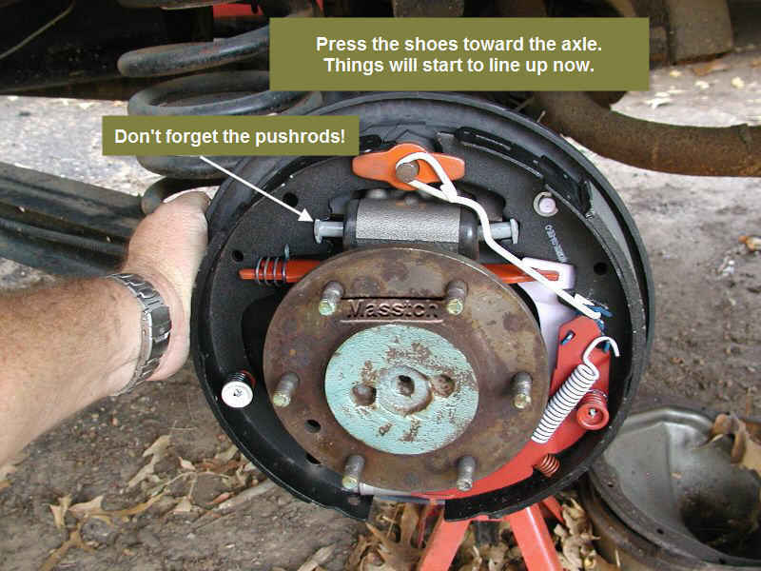
Press shoes against anchor. Install front shoe return spring to anchor.
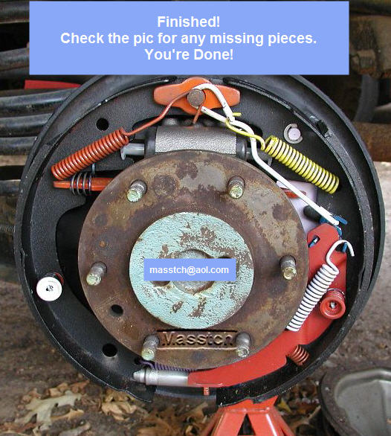
Install rear shoe spring to link as shown

