Detailed Wiper Wiring Diagram

In the middle of wiring my '73 fiberglass bodied K5 from scratch. Just finished the wipers, in case anybody is interested I thought I'd share the diagram. The GM diagrams are a little confusing and not as complete as the fuse box is not detailed anywhere. I don't have a fuse box, I'm using breakers. But this might be useful to somebody (hopefully) trying to troubleshoot their wipers or wire them from scratch.
Keep in mind, I used different colors than stock (it's hard to find black with blue stripe SXL rated wire in various gauges!) but the OEM colors are referenced in the corner.
This is for 1984 steering column and module and motor. 85-88 is the same, except I think they broke out the washer pump from the motor and put it in the washer reservoir itself, but same 2 pins and wire colors to run it. For Column mounted switch with pulse intermittent wipers. Module for 1984 is a different number than 85-91, but the 85-91 module works fine too, I tested it.
70's years I believe use the same colors, but switch and module are integrated on the dash and motor might be a bit different. I'm using new motor, switch and module.
BTW, for anybody putting the 80's style motor in their 73-80 rig, you need the crank arm with the motor! It's a separate part and is a longer reach than the 70's crank arm. GM #22038927
1984 module is 15598460 for pulse wipers
85-91 module is 15598496 for pulse wipers
non-pulse wipers are wired same just a different module and switch (look them up on http://www.gmpartsdirect.com/)
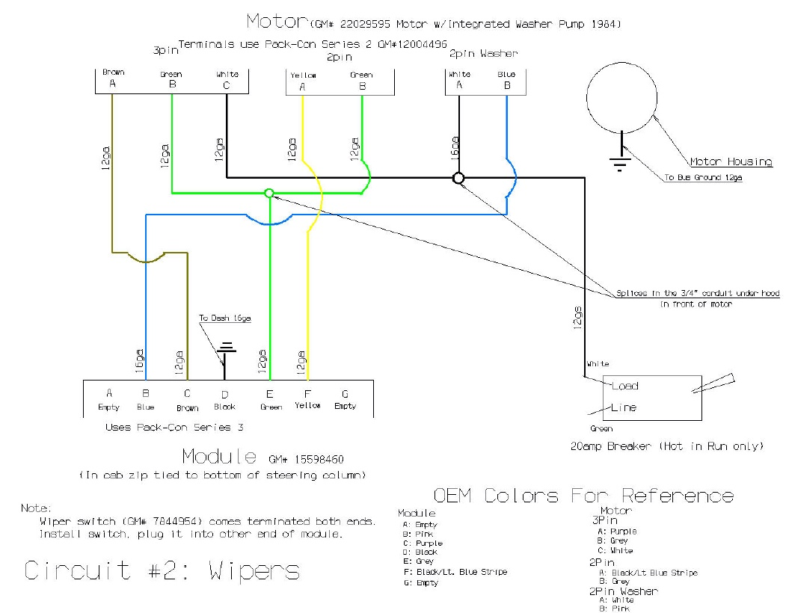

You’re right, the washer pump is just 2 wires one to bat and one 2 ground and she squirts.
But, GM wires that thing through the module and grounds it through there.
GM wired it this way
You turn on washer pump, white wire (1 to motor and 1 to pump) and one of the others at the motor becomes hot (turns on low speed wipers) and pink wire to pump grounds out through the pink wire (my diagram is blue) to module back through the black wire coming out of the module, for a period shorter than then the low speed is turned on (white hot). So wiper runs a couple of strokes after pump is done pumping. During that time, white is still hot, but pink should have no ground.
My guess is the ground side isn't grounding out. If the wipers come on, the white should be hot to the motor (it is if your wipers come on) and to the pump. The switch I believe is doing its job; it's probably your module. Take a meter or light and connect it to that white wire and hit the washer switch. You should have power on that white wire. If you do, then take a meter in ohm mode and see if you have continuity between frame and that wire. If you don't have an ohm meter, cut or splice into that wire and ground it out, pump should come on.
Check the black wire coming out of your module on the back side (not the side that connects to the switch) and ensure it has a good ground. If it does, and your white wire is hot when the switch comes on, your module is bad.
Ok...I had that a bit backwards. Sorry...what happens you turn the switch it should ground the motor out internally (to housing) with one of the other wires to motor, and that grounds the pump out through the housing. That's working, so the motor is being grounded (because you said your wipers come on, so switch is doing its job. Pink (blue on mine) wire to pump should be grounded as well when you first hit the washer. White is always hot when key is on no matter what.
Pink goes back to module and module controls the grounding through the black wire (pin d). Check that ground, if it's good, your module is bad.
Ok, it's easy (once you get it!); it's what’s called a negative switching circuit. When key is on, the white wire to pump should be hot at all times no matter the position of the wiper switch. Check for that with a meter or light. If it is, let's move on to the ground. Splice into or cut or weasel another wire into the pick wire socket at the pump wire and ground it, you should have a working pump.
Put that back (unground the pink wire)
If that works then check black wire in the cab from the module to ground. Make sure it's grounded. If it is, then your module is bad, it's not grounding out the pump. I guess the switch could be too, but I don't know how they did switch to module wiring, since that's all done for you if you buy a new switch and module.
I don't think the motor itself matters in this case. If your wipers work, don't mess with that part. The motor is grounded through the housing. The pump is grounded through switching in the module and the black wire coming out of the module.

